IPAC VISITOR EDUCATION
PACKAGE

KEEPING EVERYONE SAFE
We are committed to making sure every visit is meaningful and purposeful. We are partners and working together in making sure the residents and yourselves are as safe as possible. Equipping you with Infection Prevention and Control (IPAC) knowledge and resources will assure your success in helping to prevent the spread of any potentially contagious and/or dangerous germs.
Some basics to start with:
You will be screened at the front door and asked key questions every visit. If for some reason you do not pass the screening questions, you will be directed to next steps. Your patience is appreciated.
You may be asked to wear a mask if you are having an indoor visit. Details around when and wear you must adhere to masking policies will be explained to you. If your visit is an outdoor visit, depending on the home’s policy, you may be able to visit without a mask.
Maintain 2-meter physical distancing in circumstances where you are not familiar with a person is important. We recognize that hugs and touch are important to the well being of all and ask that you are also conscious of maintaining healthy 2-meter physical distancing where possible.
Practice hand hygiene and respiratory etiquette (move away from others when you feel a sneeze or cough coming on; cover your mouth and nose with a tissue when you sneeze or cough. If you don’t have a tissue, use your sleeve or elbow but never your hands. Discard any used tissue in a garbage container. Wash and sanitize hands immediately. Rub your hands for at least 20 seconds).
If you are sick or feel sick, please stay home. Germs are tricky and they have an amazing way of spreading even when we are not sure if we are sick.

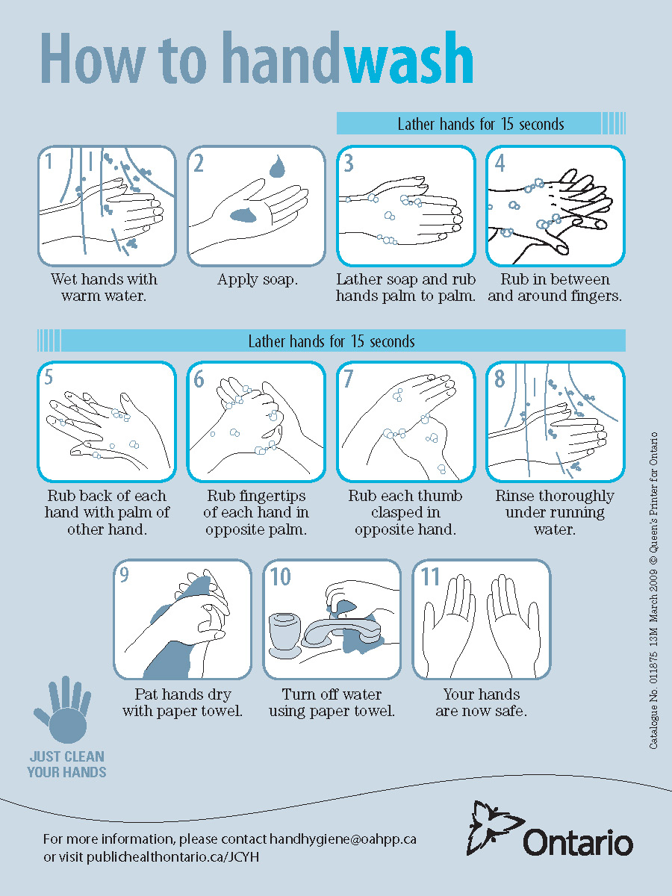
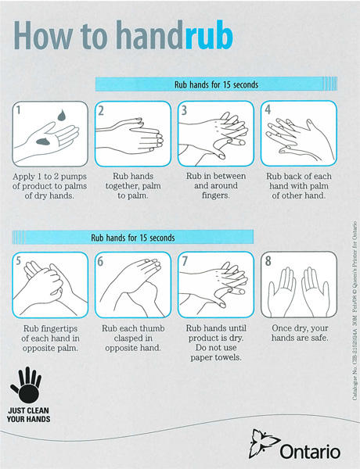

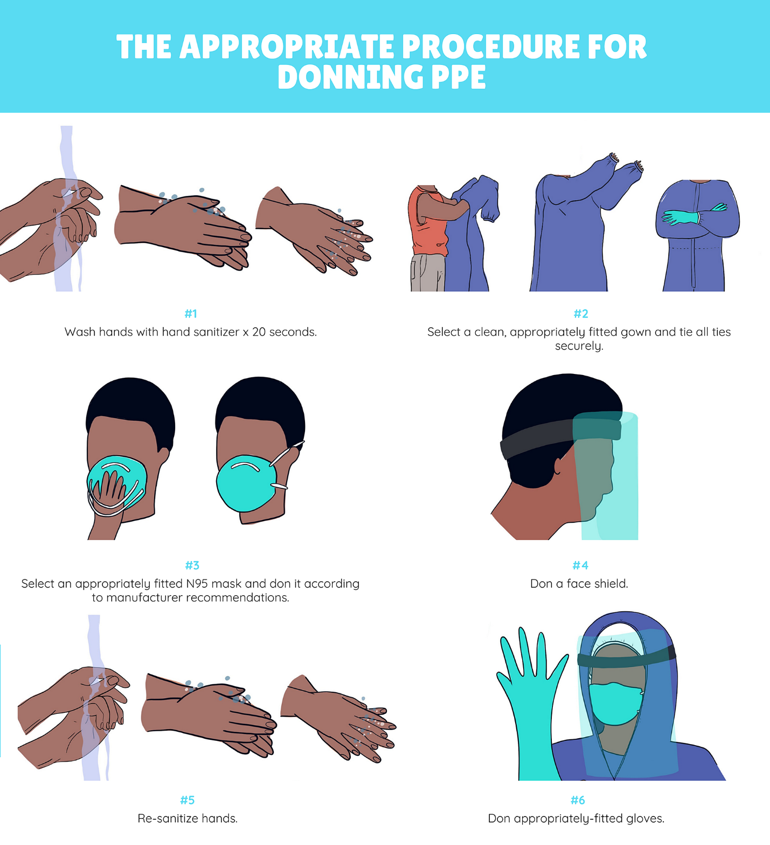

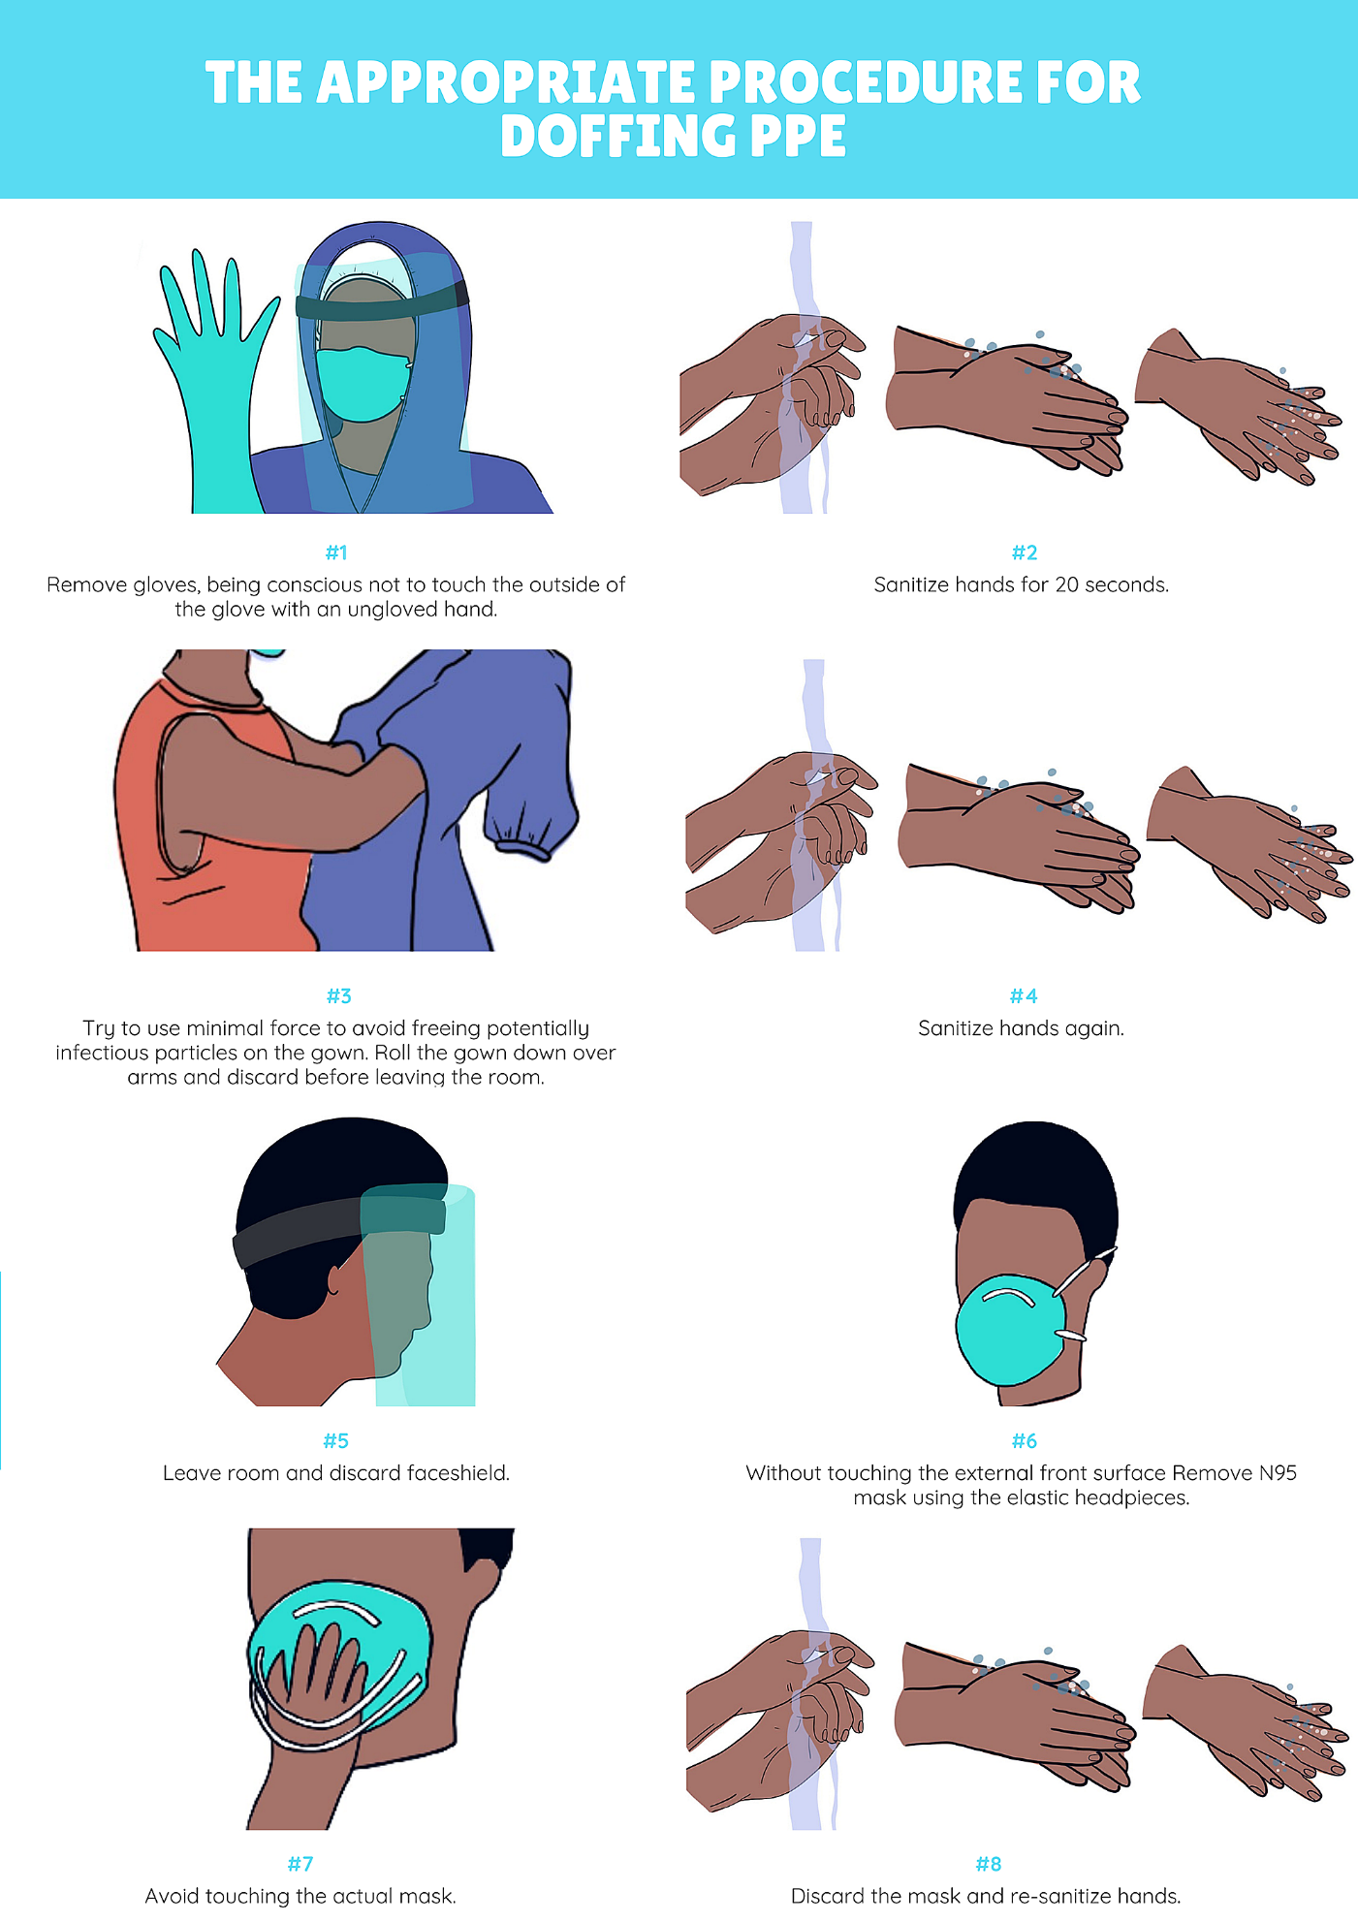
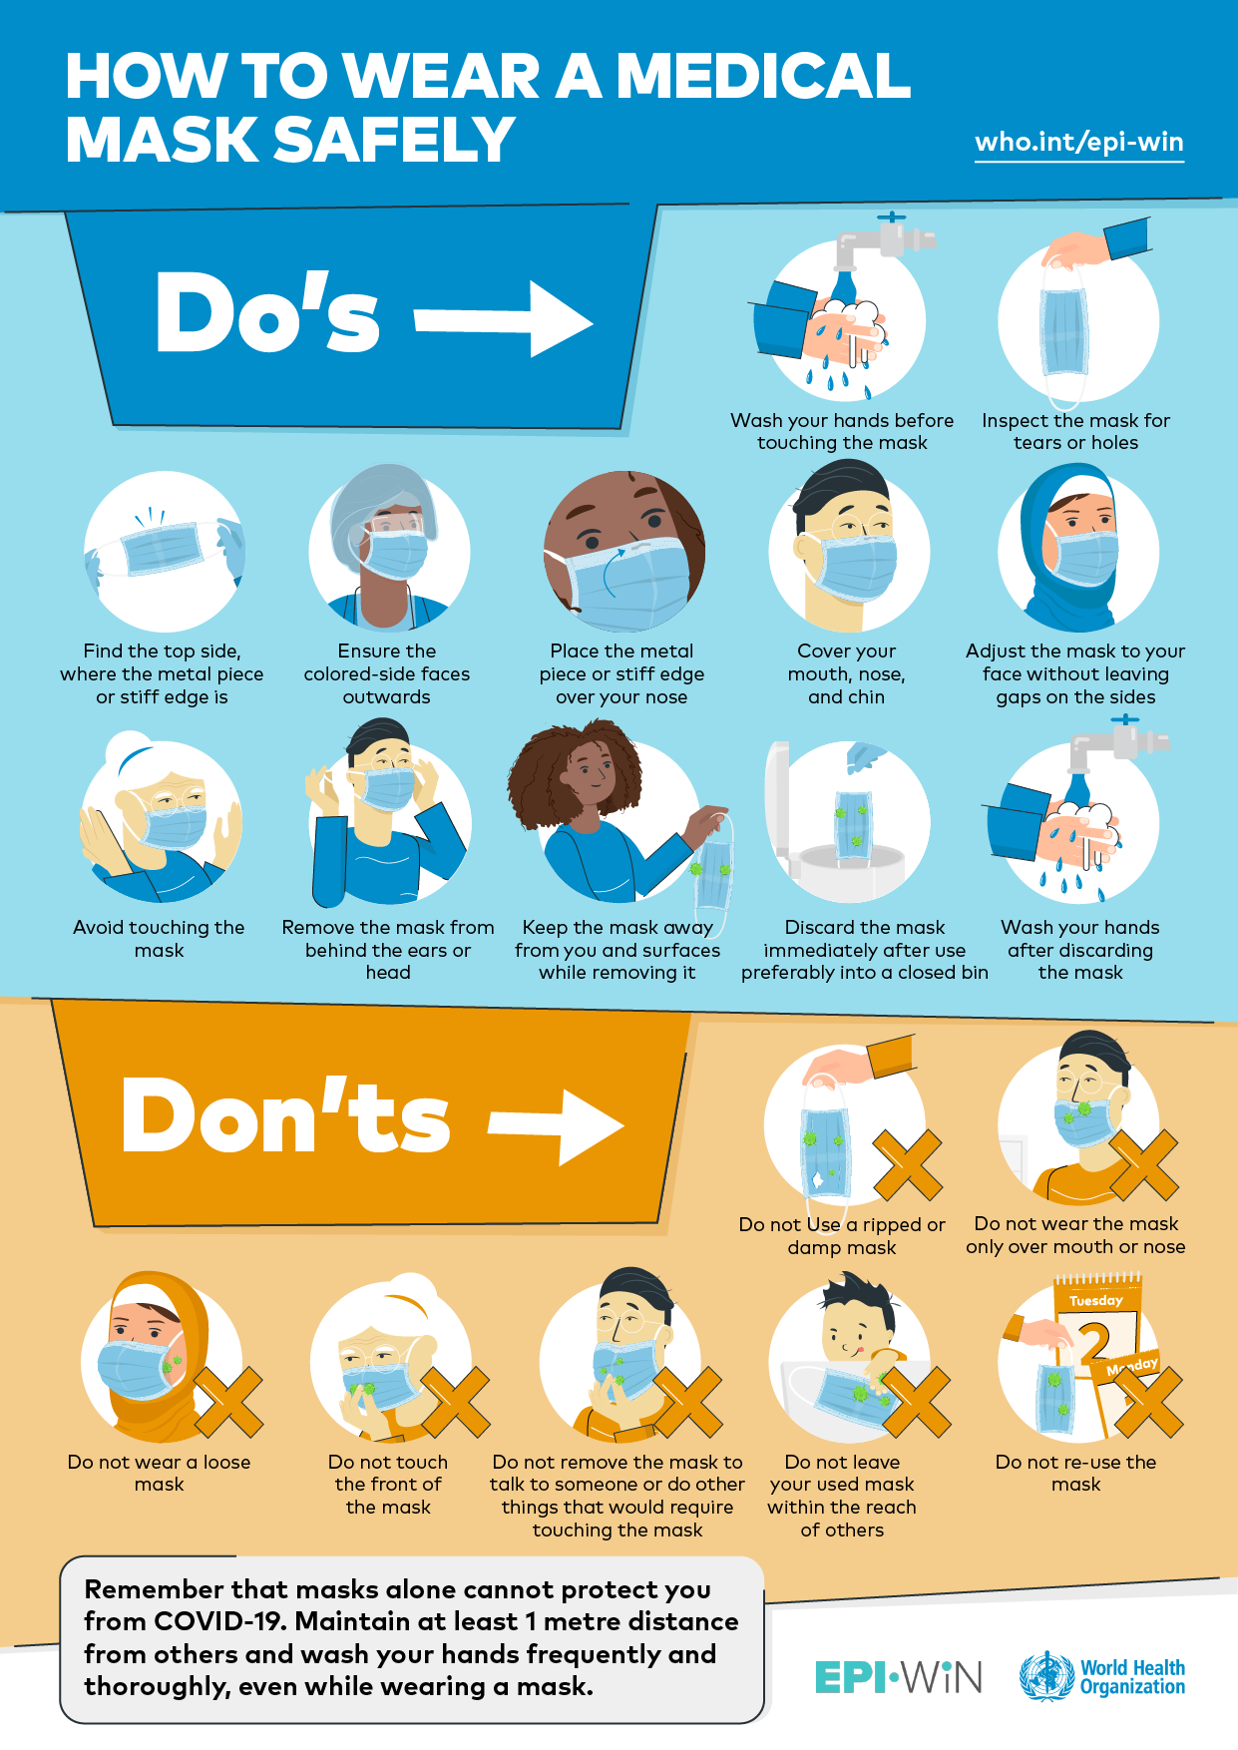
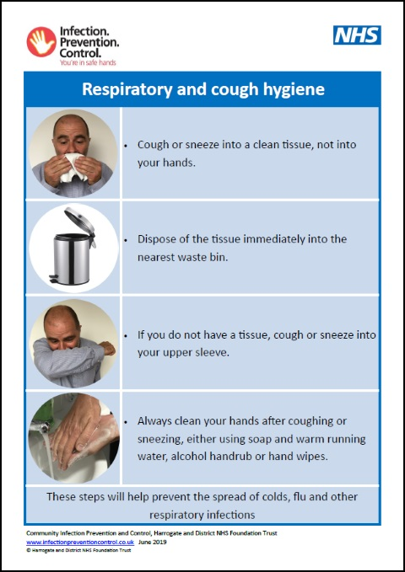

We are grateful for your adherence to the IPAC practices contained in this education package and the time you took in reviewing its contents.
Please feel free to share your feedback with us.
Home Contact Information:

